**Computation Theory: Tutorial Week 7**

**QUESTION 1**

Below is an undirected graph G = (V, E).

1. Find |V| and |E|, (i.e. the number of vertices, the number of edges), and
2. the degree of each vertex

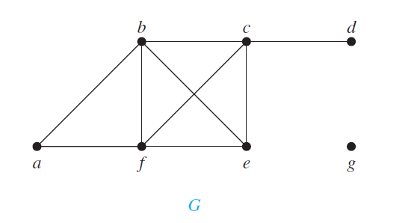

**|V| = 7**

**|E| = 9**

**Degree of a = 2**

**Degree of b = 4**

**Degree of c = 4**

**Degree of d = 1**

**Degree of e = 3**

**Degree of f = 4**

**Degree of g = 0**

**QUESTION 2**

Define and draw these graphs:

1. K7

k7

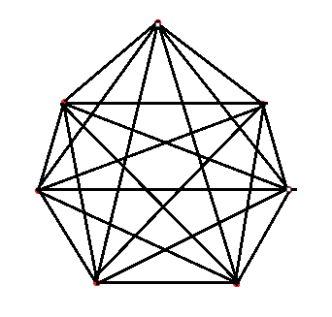

**7 vertices and every vertex has a degree of 6.**

**N(n-1)/2 = 21. There are 21 edges.**

1. K3,5

K3, 5

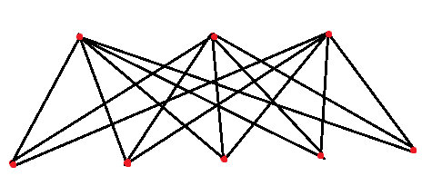

**Bipartite graph.**

**Vertices divided into 2 sets, 3 & 5, such that an edge connects a vertex in 3 to a vertex in 5.**

**It is a complete bipartite graph.**

**QUESTION 3**

How many vertices and how many edges do these graphs have?

1. *Kn*

**Kn has n vertices and n edges.**

1. *Km,n*

**K has mn vertices and mn edges**

**QUESTION 4**

For graphs i) – iv) determine whether the graph is ***bipartite.***

You may find it useful to apply this **Theorem :**

***A simple graph is bipartite if and only if it is possible to assign one of two different colours to each vertex of the graph so that no two adjacent vertices are assigned the same colour***

and answer the question by determining whether it is possible to assign either red or blue to each vertex so that no two adjacent vertices are assigned the same colour.

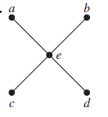

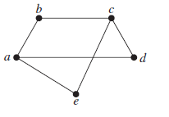**i)** **ii)**

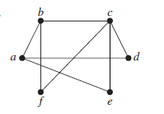

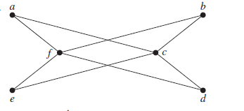



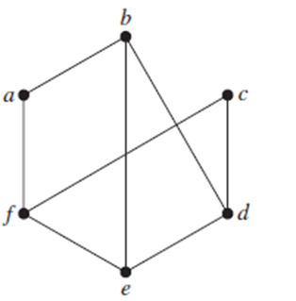

**Graph I) is bipartite**

**Graph II) is bipartite**

**Graph III) is not bipartite**

**Graph IV) is bipartite**

**Graph V) is not bipartite**

**QUESTION 5**

For each of the following three graphs, decide if it has an Eulerian path, an Eulerian circuit, both, or neither. In each case give a brief justification.

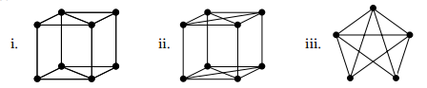

1. **Euler path – No**

**Eulerian circuit – No**

**4 vertices with odd degrees so there is neither.**

1. **Eulerian path – Yes**

**Eulerian circuit – Yes**

**All vertices have an even degree so there is both**

1. **Eulerian path – Yes**

**Eulerian circuit – No**

**2 vertices that have an odd degree so there is a path but no circuit**

**QUESTION 6**

Which of these three figures has a Hamiltonian circuit?   
Or, if there is no Hamilton circuit, a Hamiltonian path?

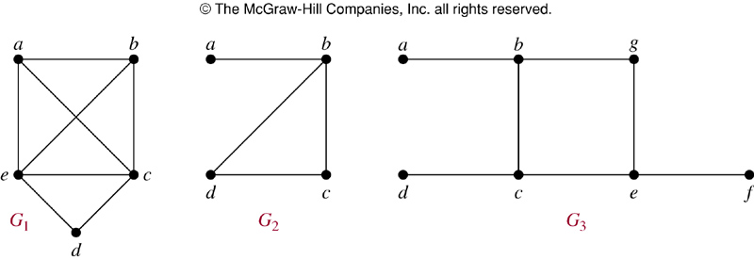

**Fig G1) Hamiltonian circuit – Yes**

**Hamiltonian path – Yes**

**Fig G2) Hamiltonian circuit – No**

**Hamiltonian path – Yes**

**Fig G3) Hamiltonian circuit – No**

**Hamiltonian path – No**